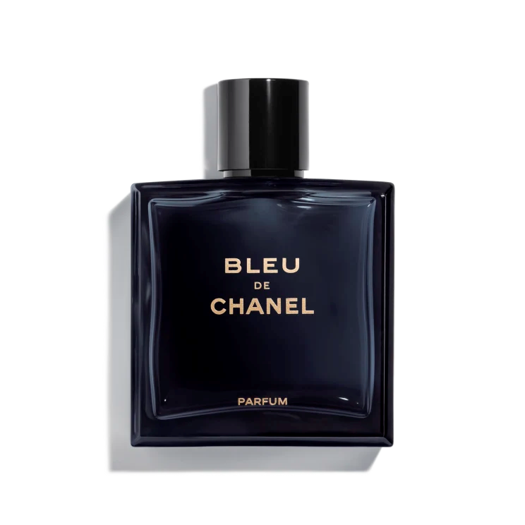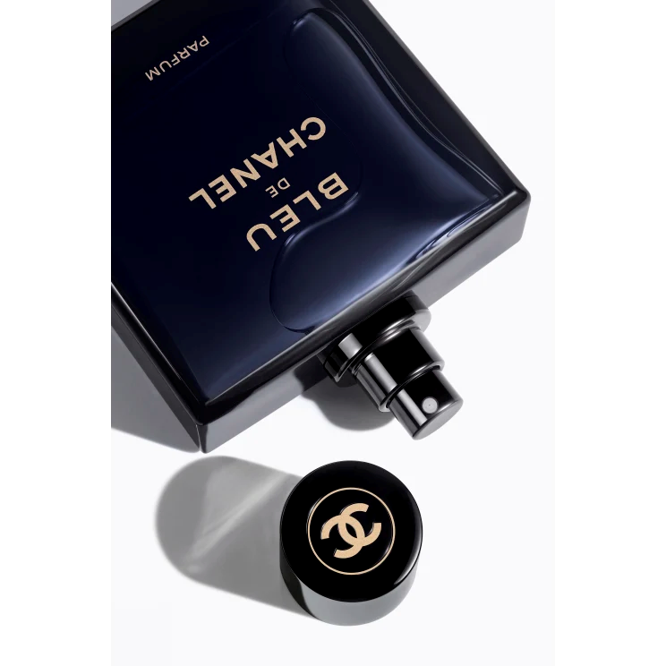

**BLEU DE CHANEL**

$185

Tax Included.

Spray 100 mL

IN STOCK

**Product Details**

The most intense of the BLEU DE CHANEL fragrances. Powerful and refined, the Parfum for men reveals the essence of independence and determination. A timeless scent with a strong masculine signature.